> restart:
with(plots);
Warning, the name changecoords has been redefined

> with(plots);

Warning, the name changecoords has been redefined

> F:=U->cos(u);

U0:=x->sin(x);

> implicitplot (u-U0(x)), x=-1..1, u=-1..1);
Error, `)` unexpected

> implicitplot (u-U0(x-diff(F(u),u)*0.7), x=-1..1, u=-1..1);
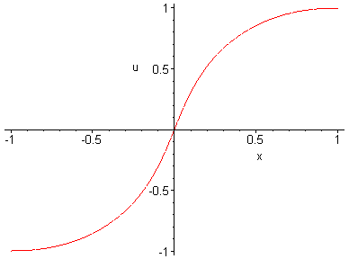
> P:=implicitplot((u-U0(x)=0, x=-1..1, u=-1..1)):
> R:=implicitplot((u-U0(x-diff(F(u),u)*0.7)=0, x=-1..1, u=-1..1),style=line,color=blue):
> display({P,R},axes=boxed,scaling=constrained,title='Uravnenie');
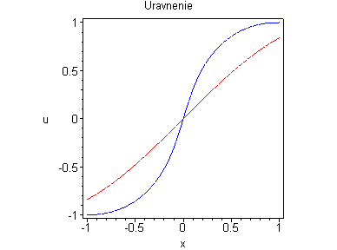
> A:=implicitplot((u-U0(x)=0, x=-1..1, u=-1..1)):

> B:=implicitplot((u-U0(x-diff(F(u),u)*0.1)=0, x=-1..1, u=-1..1),style=line,color=blue):
> C:=implicitplot((u-U0(x-diff(F(u),u)*0.2)=0, x=-1..1, u=-1..1),style=line,color=blue):
> E:=implicitplot((u-U0(x-diff(F(u),u)*0.3)=0, x=-1..1, u=-1..1),style=line,color=blue):
> T:=implicitplot((u-U0(x-diff(F(u),u)*0.4)=0, x=-1..1, u=-1..1),style=line,color=blue):
> Y:=implicitplot((u-U0(x-diff(F(u),u)*0.5)=0, x=-1..1, u=-1..1),style=line,color=blue):
> W:=implicitplot((u-U0(x-diff(F(u),u)*0.6)=0, x=-1..1, u=-1..1),style=line,color=blue):
> N:=implicitplot((u-U0(x-diff(F(u),u)*0.7)=0, x=-1..1, u=-1..1),style=line,color=blue):
> M:=implicitplot((u-U0(x-diff(F(u),u)*0.8)=0, x=-1..1, u=-1..1),style=line,color=blue):
> K:=implicitplot((u-U0(x-diff(F(u),u)*0.9)=0, x=-1..1, u=-1..1),style=line,color=blue):
> display((B,C,E,T,Y,W,N,M,K),axes=boxed,scaling=constrained);




